How to: Create AFD diagrams in SVG Format (Excel)

- Open 'Active_Format_Aspect_Ratio_Calculator_v1.3.xlsx'
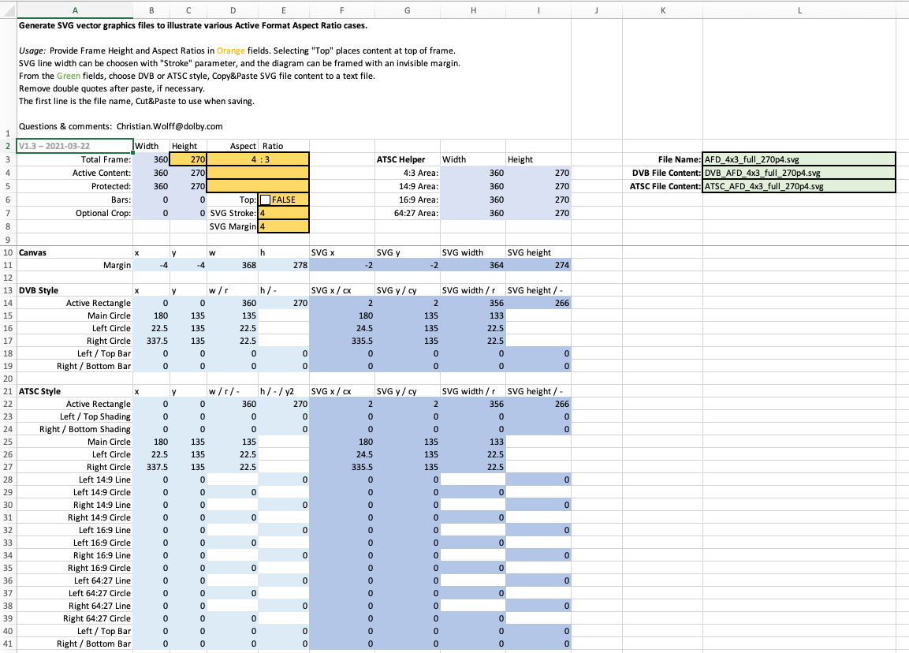
- Select desired AFD parameter
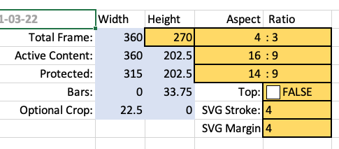
- Select desired target style (e.g. "DVB") and copy content
  - 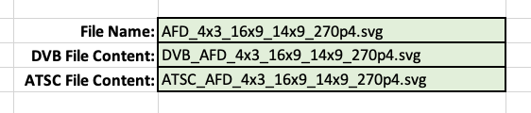
  - 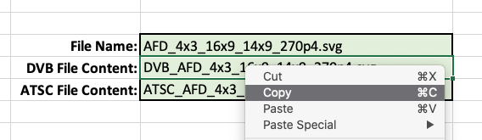
- In text editor of choice, create a new document and paste
  - 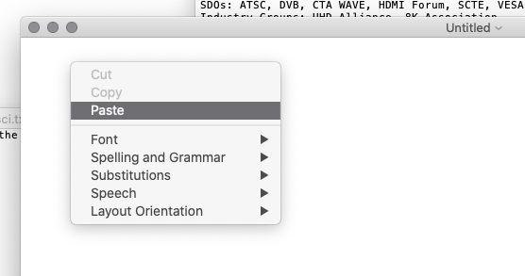
  - 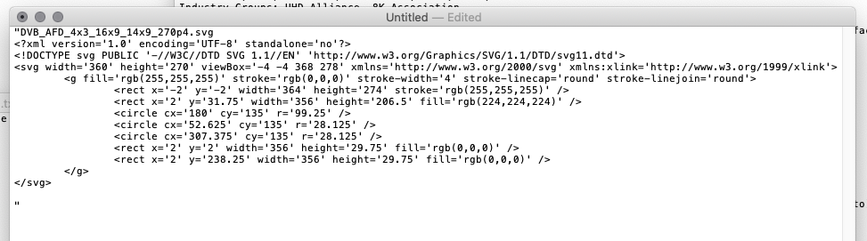
- Delete double quotes at start and end of file
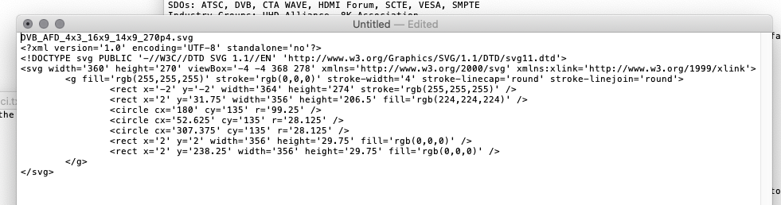
- Select and cut first line, containing the file name
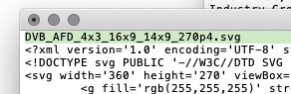
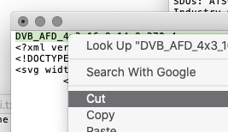
- Save file, using the cut file name
  - 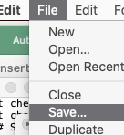
  - 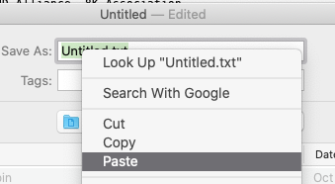
- If necessary, delete trailing space
  - 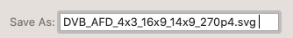
  - 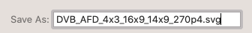
- Make sure to use ".svg" file name extension
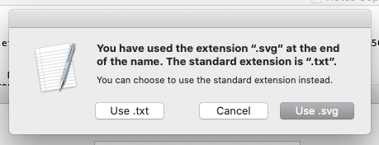
- File looks good
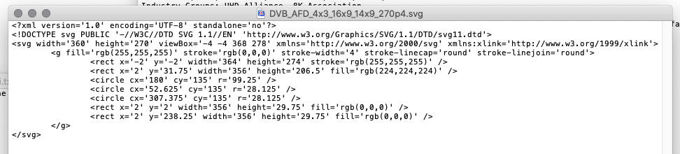
- Open file in web browser
  - 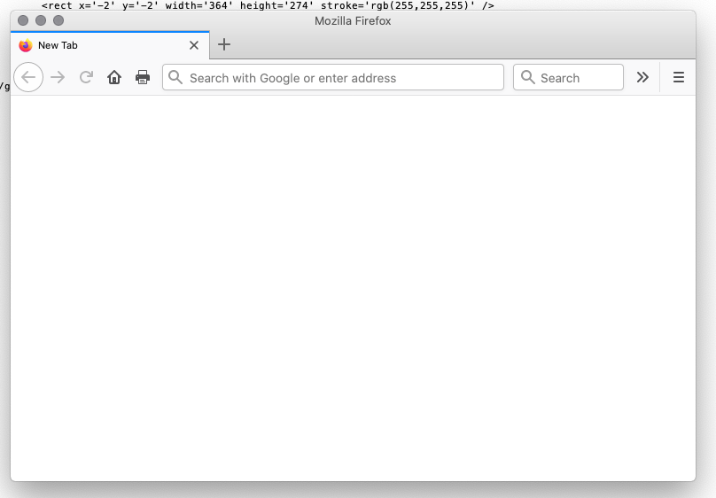
  - 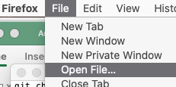
  - 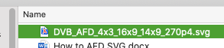
- Verify diagram looks as expected
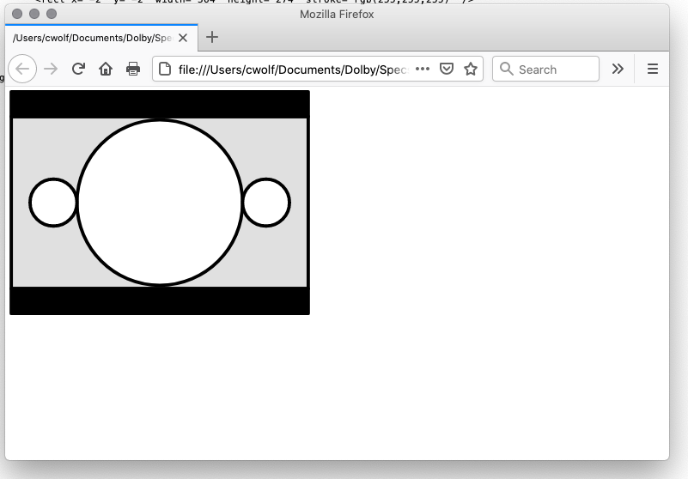

How to: Create AFD diagrams in SVG Format (Perl script)

- Open a shell
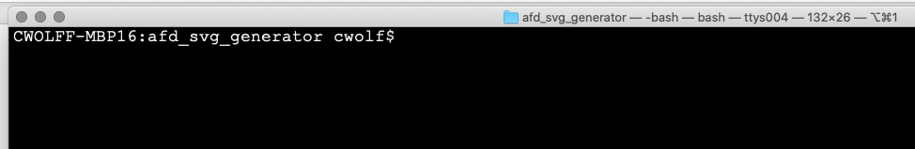
- Run perl script with '-help' option for detailed instructions
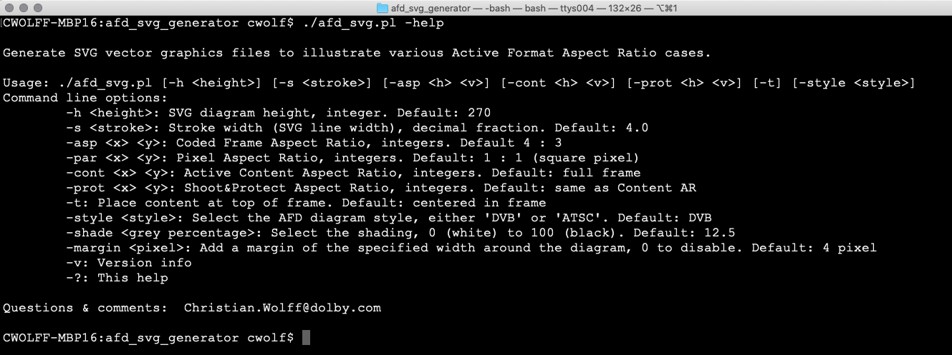
NB.: '-par' option is implemented in version 1.4 and above of the script
- Run perl script with desired AFD parameters
- Where bash shell is available, the 'afd_svg_set.sh' shell script will generate a full set of AFDs in a folder
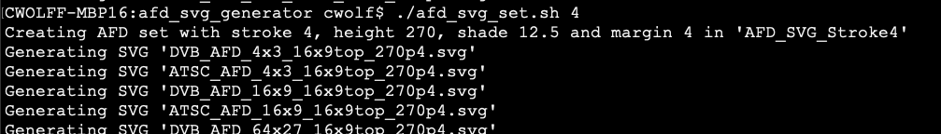
[ ... ]
- Verify generated files in web browser, see step 11 above

How to: Embed AFD diagrams in CTA-861 Word document

- Click on diagram to be replaced, to select it
  - 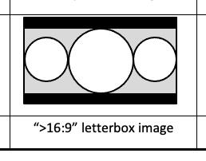
  - 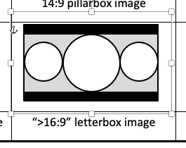
- Delete the old diagram, with Del / Backspace
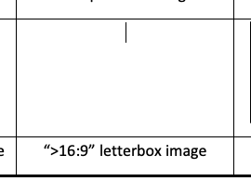
- Place the cursor where the diagram was, and select from the menu "Insert" --> "Pictures" --> "Picture from File..."
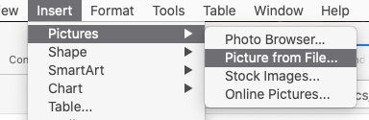
- Choose desired replacement file and click "Insert"
  - 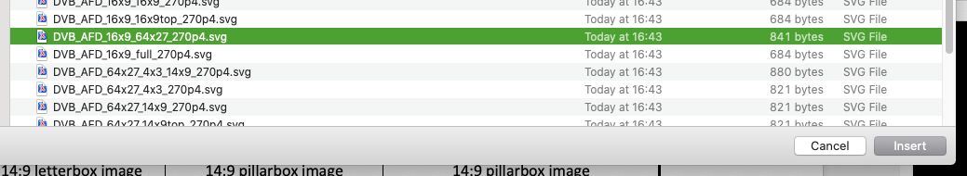
  - 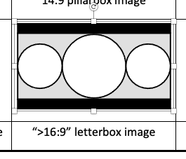
- Adjust picture size, e.g. by setting a unified height. Make sure Height and Width are locked to each other
  - 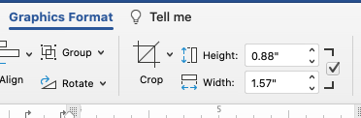
  - 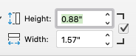
  - 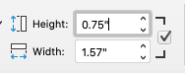
  - 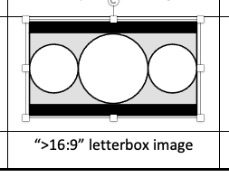
- De-select the picture
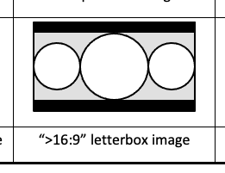
- Done.

How to: Convert Word file to PDF

- Use MS Word for Windows. Word for Mac and the online version on office365.com are insufficient and will not maintain SVG graphics as vector format in PDFs.
- Select "File" --> "Save As..." and select "PDF (*.pdf)" (do not use "Print to PDF"!)
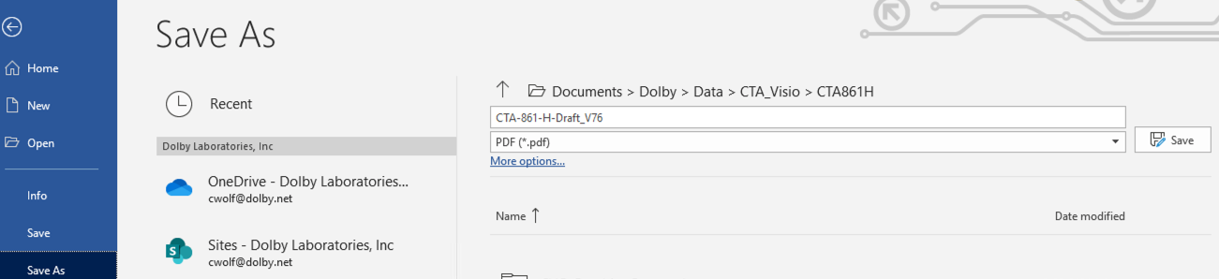
- In "More options...", make sure that PDF format is "Standard":
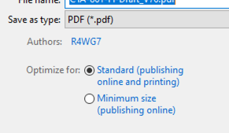
- Select a destination folder and a file name, if needed, then save the file.

